Exploring Symmetric and Asymmetric Cryptosystems
Executive Summary
This report examines the fundamental principles of cryptography, focusing on symmetric and asymmetric encryption methods. It discusses classical ciphers, their limitations in the modern digital landscape, and the necessity for more robust encryption techniques. The report provides an in-depth analysis of modern symmetric ciphers, such as the Advanced Encryption Standard (AES) and Triple Data Encryption Standard (3DES), as well as asymmetric ciphers, with a particular emphasis on the RSA algorithm. It concludes with recommendations for implementing a hybrid cryptographic approach to secure sensitive data within a private healthcare organization.

Introduction
A cipher is a method used to convert plaintext into ciphertext, rendering the original information unreadable to unauthorized individuals. Historically, ciphers like the Caesar Cipher and the Vigenère Cipher were employed to protect sensitive information.
- Caesar Cipher: This substitution cipher shifts each letter of the plaintext by a fixed number of positions in the alphabet. For example, with a shift of three, 'A' becomes 'D', 'B' becomes 'E', and so on. While simple, it is easily broken through frequency analysis or brute-force attacks due to its limited key space (GeeksforGeeks, 2024).
- Vigenère Cipher: This polyalphabetic cipher uses a keyword to determine the shift for each letter, providing more security than the Caesar Cipher. However, it is still vulnerable to attacks such as the Kasiski examination and frequency analysis (IBM, 2024).
These classical ciphers lack the complexity required to withstand modern computational attacks. The advent of computers has enabled attackers to perform rapid brute-force attacks and sophisticated cryptanalysis, rendering these historic ciphers ineffective for protecting digital information. Consequently, more robust and complex ciphers are essential to ensure data security in today's digital world.

Symmetric Ciphers
Symmetric encryption involves the use of a single secret key for both encryption and decryption processes. This key must be shared and kept confidential between the communicating parties. Modern symmetric ciphers are designed to be computationally efficient and secure.
Examples of Modern Symmetric Ciphers:
- Advanced Encryption Standard (AES): AES is a widely adopted block cipher that encrypts data in fixed-size blocks of 128 bits, using key sizes of 128, 192, or 256 bits. It is known for its high performance and strong security, making it suitable for various applications, including securing sensitive data in healthcare systems (Schneier, 2024).
- Triple Data Encryption Standard (3DES): An enhancement of the older DES algorithm, 3DES applies the DES algorithm three times to each data block, increasing its security. However, it is slower compared to AES and is gradually being phased out in favor of more efficient algorithms (GeeksforGeeks, 2024).
Advantages:
- Speed: Symmetric encryption is computationally efficient, ideal for real-time data encryption.
- Simplicity: A single key simplifies the encryption and decryption process.
Drawbacks:
- Key Distribution: Securely sharing the key between parties can be challenging.
- Scalability: Managing keys for multiple parties becomes complex as the number of users grows (IBM, 2024).

Public Key Ciphers
Asymmetric cryptography, also known as public key cryptography, uses a pair of keys—a public key for encryption and a private key for decryption. The RSA algorithm is a foundational example of this method.
How RSA Works:
- Key Generation: Large prime numbers are selected, and their product forms the modulus for both keys.
- Encryption: The public key encrypts the plaintext into ciphertext.
- Decryption: The private key decrypts the ciphertext back to plaintext.
Example:
- Prime numbers:
- Modulus:
- Public key exponent:
- Private key exponent: (Schneier, 2024).
Advantages:
- Key Management: No need to share private keys, reducing the risk of compromise.
- Scalability: Suitable for environments with numerous users.
Drawbacks:
- Performance: Computationally intensive, making it slower than symmetric encryption.
- Key Size: Requires larger keys to achieve equivalent security (IBM, 2024).

Case Studies in Cryptographic Failures
1. British NHS WannaCry Ransomware Attack (2017)
What Happened:
The WannaCry ransomware attack exploited vulnerabilities in outdated systems, encrypting critical patient data and disrupting healthcare services across the UK. The malware spread rapidly, affecting hospitals and clinics, causing thousands of appointments and surgeries to be cancelled (BBC News, 2017).
Consequences:
The attack led to significant operational disruptions and financial losses, costing the NHS millions. Critical services were delayed, impacting patient care. The attack highlighted the urgent need for stronger cybersecurity measures (BBC News, 2017).
How Prevention Methods Could Have Helped:
Using AES for encrypting sensitive data would have ensured that even if ransomware encrypted files, the original data would remain protected and confidential. Employing RSA for secure communication could have safeguarded key exchanges, preventing unauthorized access to cryptographic keys. Additionally, hash functions like SHA-256 could have detected unauthorized tampering in critical system files, enabling quicker identification and mitigation of vulnerabilities.

2. SingHealth Data Breach (2018)
What Happened:
Attackers accessed the personal records of 1.5 million patients, including the Prime Minister of Singapore. Weak cryptographic controls and insufficient monitoring allowed the breach to occur. Data was exfiltrated over an extended period without detection (The Straits Times, 2018).
Consequences:
The breach led to widespread public outrage and operational disruptions. It undermined trust in the healthcare system and prompted significant regulatory scrutiny (The Straits Times, 2018).
How Prevention Methods Could Have Helped:
Encrypting all sensitive data with AES would have rendered exfiltrated data unusable to attackers. Utilizing RSA for secure key exchange could have protected communication channels, preventing key interception. Hash functions like SHA-256 could have been used to verify data integrity, ensuring that unauthorized modifications were promptly detected. Together, these methods would have significantly enhanced the security posture of the system.

Recommendations and Conclusions
For the healthcare organization, a hybrid cryptographic solution is recommended:
- Symmetric Encryption: Use AES for encrypting large volumes of patient data due to its efficiency and strong security.
- Asymmetric Encryption: Employ RSA for secure key exchange, ensuring that symmetric keys are distributed securely.
- Hash Functions: Integrate hash functions like SHA-256 to verify data integrity and detect tampering.
This combination leverages the strengths of both cryptographic systems to provide comprehensive security. AES ensures fast and secure data encryption, while RSA facilitates secure key management, addressing the organization’s needs for confidentiality, integrity, and scalability.

On CrypTool, I’ve used the AES Encryption/Decryption tool to encrypt plain text, you can see in the screenshots below I’m using the aes-256-cbc symmetric cypher to encrypt the plain text ‘healthcare Crypto’ with the password to decrypt the text being ‘abc’

In the screenshot below you can see the encrypted plain text being printed
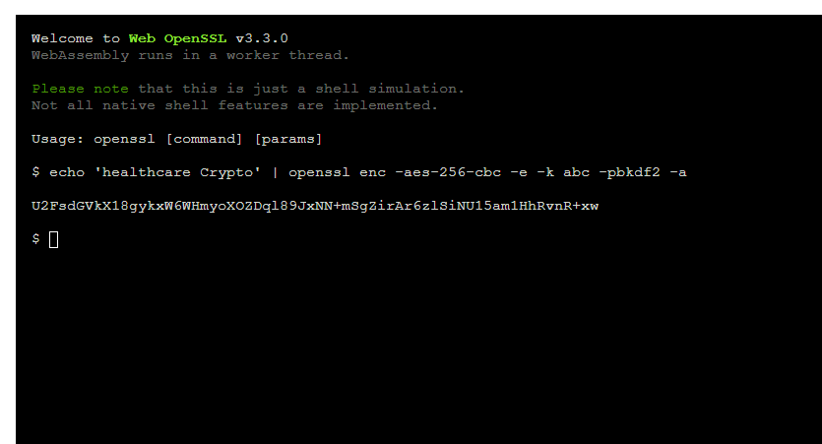

In the screenshot below you can see the inserted encrypted text into there with the password that was set previously that’s going to now be used to decrypt the encrypted text back into plain text that we can read

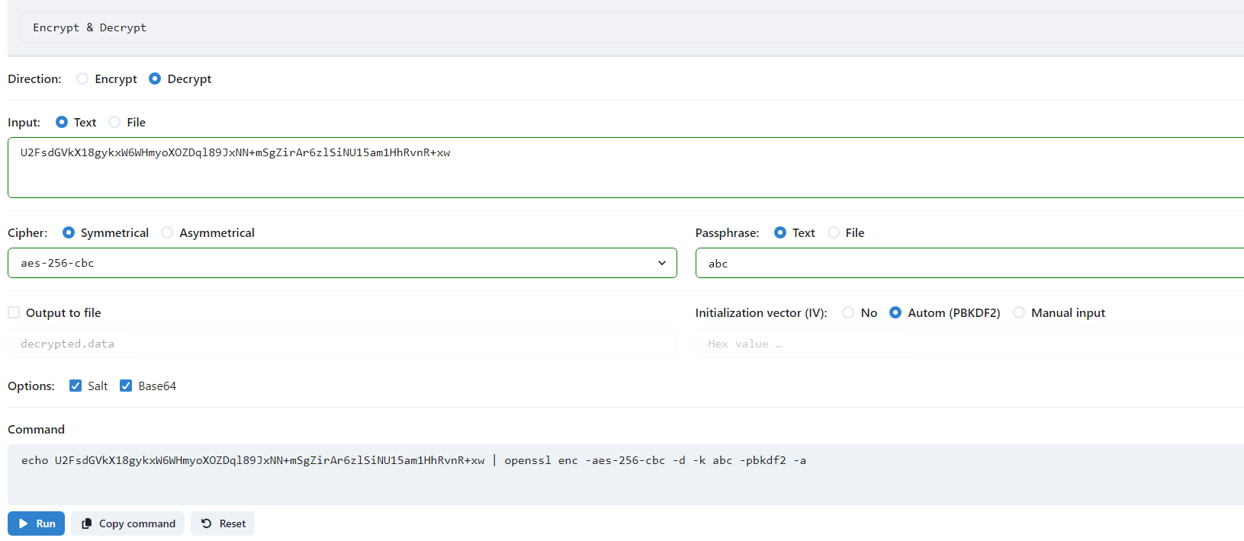

Finally in the screenshot below you can see the decrypted text now get printed showing a successful encryption/decryption exchange

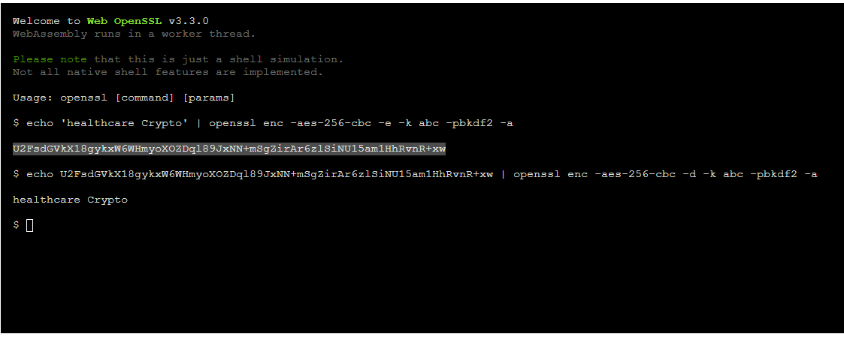

References
- BBC News. (2017). NHS cyber-attack: Everything you need to know about 'WannaCry'. Retrieved from https://www.bbc.com/news/health-39899646
- GeeksforGeeks. (2024). Cryptography and its Types. Retrieved from https://www.geeksforgeeks.org/cryptography-and-its-types/
- IBM. (2024). What is cryptography? Retrieved from https://www.ibm.com/topics/cryptography
- Schneier, B. (2024). An Overview of Cryptography. Retrieved from the uploaded document.
- The Straits Times. (2018). How SingHealth cyber attack unfolded. Retrieved from https://www.straitstimes.com/singapore/how-singhealth-cyber-attack-unfolded

